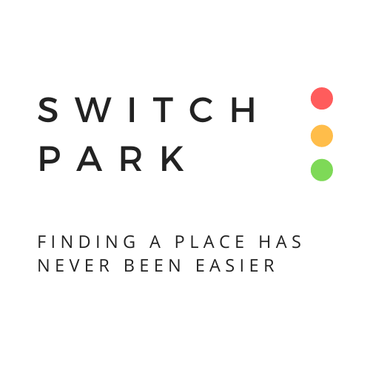

Table of contents
1 Object 2
2 Project : creation of Switchpark 2
3 Presentation of us 5
4 The market of parking rent 6
5 Customers 6
6 The competition 6
7 Location 7
8 Forecast 8
9 Funding 8

Part 1 – Project display

Object
The purpose of this document is to provide all the elements necessary for the creation of a software to rent out parking spaces between individuals.

Project : creation of Switchpark
- Legal form
In the framework of the creation of our company, we opted for a SAS legal status (Société par Action Simplifiée or “Simplified Joint-Stock Company”), according to the possibility of flexibility in the future.
Indeed, the social and tax benefits provided by this status differ from other legal forms such as SA (Société Anonyme or “Limited Company”) and SARL (Société à Responsabilité Limitée or “Limited Liability Company”). SAS status is for us the most suitable status in order to emerge on a new market.
Even if SARL can work in every sector and switch into a SAS, there is little room to manoeuvre and let partners decide how to organize the operation of the company.
Furthermore, SAS status allows a great freedom as regards the operation and organisation of the company - it is why this status is so particular. Benefiting from the SAS status also means not being limited to the number of shareholders and capital. The manager of an SAS also has decisive advantage allowing him to be affiliated to the general Social Security scheme, a system which is less restrictive.
- Field of activity

“ Finding a place has never been easier ”

The core business of the company is first the linking of prospects wishing to rent their parking space or garage with a second prospect category searching a parking place.
The rental period of the space will depend on the time chosen by the tenant which can range from a few hours to several weeks.

- Our logo
- Operation of our application
- Creating an accompt
After downloading the application, members must enter personal data (first name, last name, gender, age, picture, postal address, dd, phone number, email address and ID Card). These elements are going to build up tenants’ trust and at the same time provide security to the application.
Once a tenant achieved most of the procedures regarding the register, he could have access to the map with available places in order to choose his desired location.
Through this, he will also be able to obtain the contact details of the lessor and therefore discuss with him for any additional questions.
- Payment (Bank Transaction)
Once the rental is completed, the lessor will be immediately debited for the amount agreed by the tenant. The latter will be credited by our company with the amount provided via its bank details provided.
- Overview of available places
Members of the application will have a complete image of the available places (in green) in the searched area.

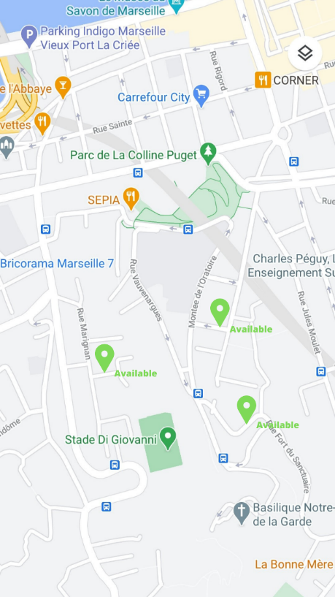

- Further information
Following the choice of his place, the tenant will benefit from additional information to his rental. Namely, GPS coordinates, address, phone number and date.
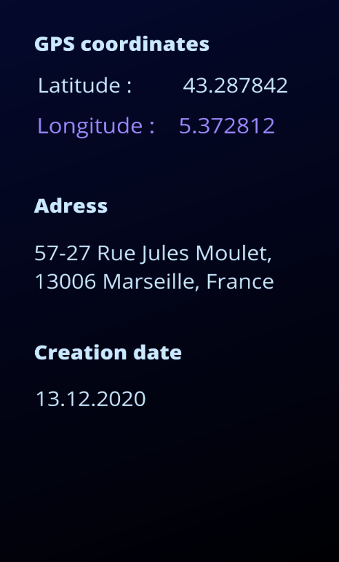

- Picture of the place
In order for the customer to find the space as easily as possible, an image of the location will be offered.

- Contact the lessor
The phone number of the lessor will also be set a disposition of the tenant in order to let him benefit from additional information and thus facilitate the operation.
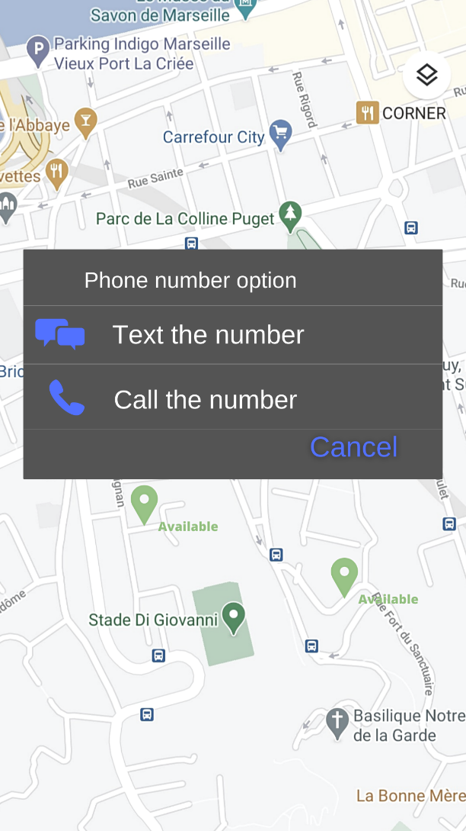

Presentation of us

LE MELLEC Florine

DUT GEA (Corporate and Administrative Management) in Aix-Marseille University
- 2-year-university degree
DUETI (DU International Business and Administration Management) at Andrzej Frycz Modrzewski Krakow University
- 1-year-university degree

- Responsible for software development
PASTORELLI Clément

DUT TC (Techniques de Commercialisation) in Aix-Marseille University
- 2-year-university degree
DUETI (DU International Business and Administration Management) at Andrzej Frycz Modrzewski Krakow University
- 1-year-university degree

- Commercial activity management

The market of parking rent
The market of parking rent in Poland is a niche market, the number of economic players on the supply side is small, so the margin potential will be higher.

Customers

The competition
The parking space market remains very little competition, the possibility of development therefore remains very strong for SwitchPark (no direct competitor in the PACA region). We will subsequently find indirect competitors such as Relais and Krypton Parkings. Considering the emergence of carpooling in all cities is also essential with the development of large platforms, such as Blablacar but also taxis such as Uber. The elimination of free on-street parking is also a real opportunity for the company.

Location
We decided to choose Marseille to start launching our application. Both of us (Clément PASTORELLI and Florine LE MELLEC) are from Marseille and we notice over the past years that there is a serious matter about finding a place to park in the city.
Marseille is an atypical city with tiny roads, not wide sidewalks, a lot of buildings/houses; and almost all the time it is a lot of struggle to find a place in the center - just to park our car close to our house.
There are 16 districts in Marseille, it is a very extended city (23,6 km by car if you want to go to the 16th district starting in the more far away point in the 8th block). For instance, Paris measures 105,4 km² while Marseille measures 240,6 km².

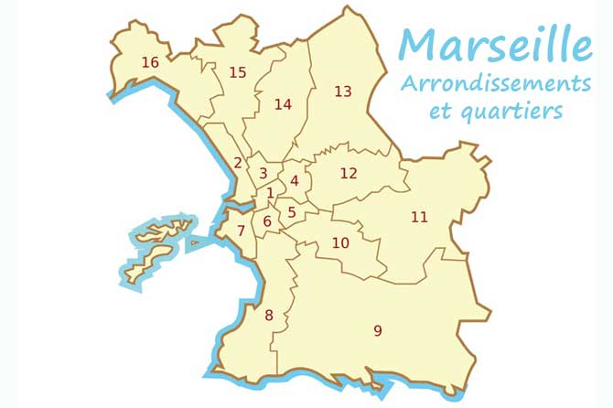

With all this space, we wonder how it is possible to NOT find a place. But the city center only includes 1st, 2nd, 3rd, 4th, 5th, and 6th district.
The space is very limited (especially in the 1st district, the “Vieux Port”) and complicated to see if there is a free place with all the tiny streets, the large buildings and wrong way signs.
It is why Marseille needs Switch Park: help people to find unseen place not far away of their house.
Our next target will be Paris and Lyon. We need to focus on huge cities first, even if there are a lot of medium or small cities have the same problem.

Forecast
For the first year, we can estimate that 93 000 simple spaces can be rented, and 22 320 garages spaces can be rented. Then every year, this will increase by 20%.
The price per hour will be 4€50 for the simple space during the week and 3€50 during the weekend.
The price per hour will be 5€50 for the garage during the week and 4€50 during the weekend.

Funding
After studying the business plan, we can apport 10 300 € (6000 € in capital and 4300 € in current amount). We are seeking the following funding:
- 2% bank loan over 7 years : 48 500 €
- leasing : 7355 €
Part 2 contains the Excel table with the data details.

Part 2 – Forecast (Excel)

SUMMARY OF THE FORECAST
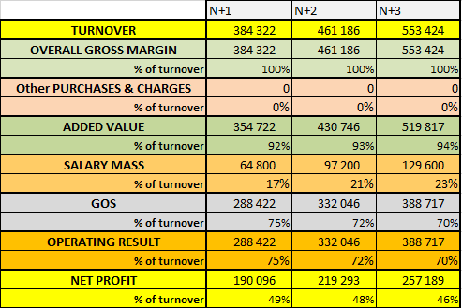

INITIAL FINANCING PLAN

